**REV’S COMPREHENSIVE**

**TFR ICON GUIDE**

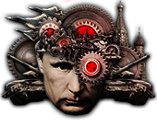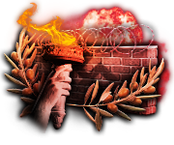

Hi. I’m Rev, a GFX artist for TFR. Throughout my time I have seen icon guides made before, and while they were good, they have either been wiped from existence for one reason or another, or weren’t used properly by the people.

Despite that, I’ve still seen many people with great potential yet with nowhere to look when it comes to how to do better in terms of making icons, and plenty more simply asking the question, “How do I make TFR-style icons?”

So, as promised, I’m here to deliver a quick and hopefully easy to follow guide to turn your icons from slop to awesome sigma TFR-style greatness.

**DISCLAIMER:**

*While it’s possible to use other apps such as GIMP or paint.net for this process, I, along with practically every other artist on the team, uses photoshop, and thus this guide will only really cover that. You can try to follow along on another program, but for your own benefit, I would recommend just getting photoshop by whatever means.*

**USEFUL PROGRAMS:**

remove.bg - Website that will automatically remove the background from any image you paste into it, extremely helpful for getting assets.

Google images/Yandex - Both are my primary sources for finding images/assets. If you can’t find something in one, you can check the other. While an image source can be anything, it’s important for newcomers to know that most of the time we aren’t using some crazy undercover sources to find assets.

**—-----------------—-----------------—-----------------—-----------------—-----------------—-----**

**THE BASICS**

First, you should open a canvas that is 170x150px large.

Fill the background with a dark gray, (*NOT BLACK*,) and on another layer fill the bottom 38-40 pixels with a bright color. I used red.

This bottom bar will act in place of where the name of the focus itself will go once the icon is in-game. If you go past this bar too much, your icon will overlap with the name of the icon. If you don’t include it at all, the icon will not be placed properly.

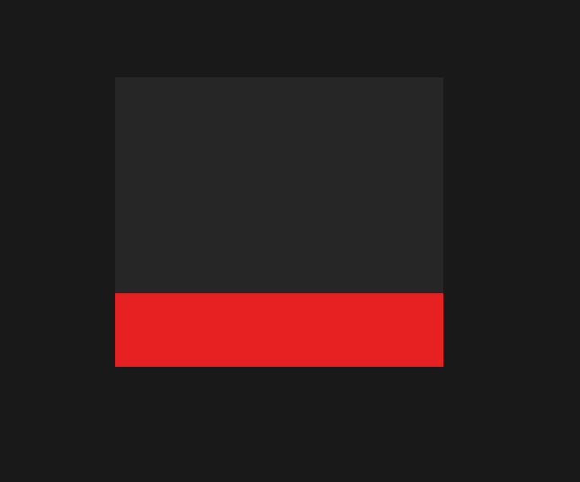

**MAKING THE ICON**

Now, you want to find an asset, whether it be an already cut out picture you have, or using the remove.bg source provided, drag your asset into photoshop. For my example I'm using a simple image of Trump.

A *very* important thing to remember when pulling your assets in is to always make sure that before you begin editing, your asset must be a smart object. This simplifies editing later on.



**APPLYING EFFECTS**

Now, we make it look good. I’m going to link the icon I make [[here](https://drive.google.com/file/d/1E8CvI4fTq7UDMZypl4cLjkL4UL_ffL_k/view?usp=sharing)] so that you can copy the layer styles. Note that you will have to often edit these and play with them at times to make your icon look the way you need it to.

It would be a good time to note that you should ALWAYS prioritize the aesthetics of your work over the rules here. The presets provide a good baseline, but if something doesn't look quite right, *never* be afraid to tweak it to your heart’s content.

Some good points of reference on all icons in our style are as follows:

* Always a strong shadow. We use both a drop shadow and outer glow simultaneously for a thick shadow.
* A vibrant gradient. We always keep our icons very colorful, often bright.
* A light bevel. Not so light it can’t be seen, but sometimes people make the bevel extremely thick and/or hard. Just enough to punctuate it.

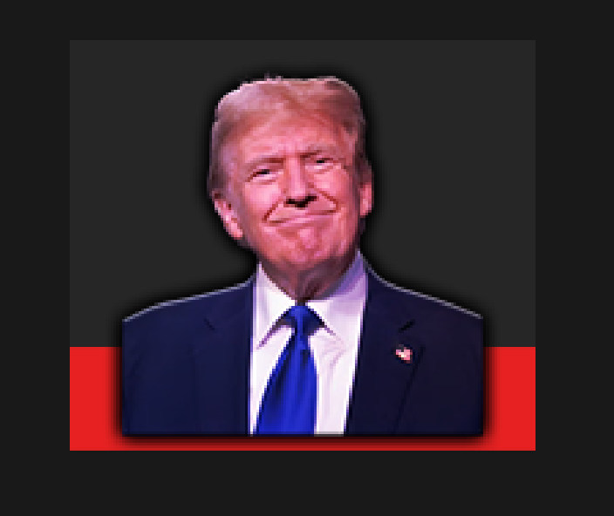

Hold on though.. It looks good, but it could be better.

Something many people, even at times people on the team overlook, is the balance of the lighting on the asset itself.

While this isn’t necessary on every icon, if it already has good shadows and contrast definition, this step can be skipped - however, I will explain how to do it here.

All you need to do is to look at the properties tab and click “Edit Contents.”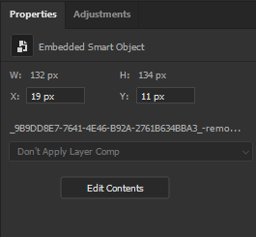

Once you are in, you will look at the top of the screen, and click “Filter.” Open the “Camera Raw Filter” part.

Once in the Camera Raw Filter, raise (or lower) the contrast to bring out the shadows more. Play with the highlights and other things to maximize your definition. Once you are done, you can save and find your way back to the main icon.

Now.. doesn’t the definition of the asset look so much better!?

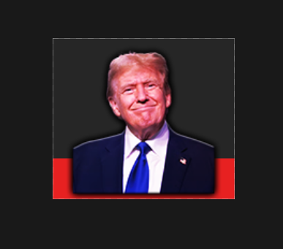

There is one final thing you might notice-

The asset is completely overlapping the red of the icon! Does this mean we have to make it smaller? Of course not!

What you’re going to do is either press ‘E’ or select manually the eraser tool, and at the top left, move the slider so the hardness is at ZERO, and the size of the brush is anywhere from like 50-70. (I know it’s not in the picture.)

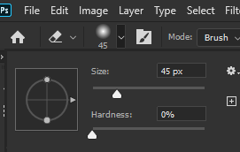

Now, select the layer of your asset, and on the bottom right click this button to make a layer mask. With the layer mask selected, begin to erase the bottom parts that overlap onto the red.



Perfect! Now your asset is completely done. You can make any other tweaks you want on your own.

Now I will add some of my own extras to finish it up and show the final product.

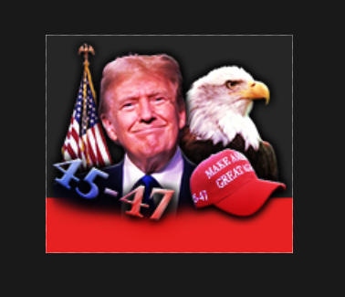

Looking amazing, and totally ready to be put in game!

As you get more used to the program, you will experiment more and you will naturally learn more tricks. That’s a good thing- and like I said before you should never be afraid to think outside the box. That’s what art is all about.

Happy Icon making!

**FAQ**

Q: I can’t edit my icon once it's a smart object!

A: Like you may have already figured out in the eraser part of the guide, you will have to use a layer mask for any posterior edits not done in the contents section.

–This list is dynamic and will periodically be updated as people start asking more questions–